WEEBLY Account Set up

Steps | Screen Image | Narration/words
1 |  | -Create your free account.  -Select SITE for choice.  -Watch the short video for  some tutorial help.
2 | 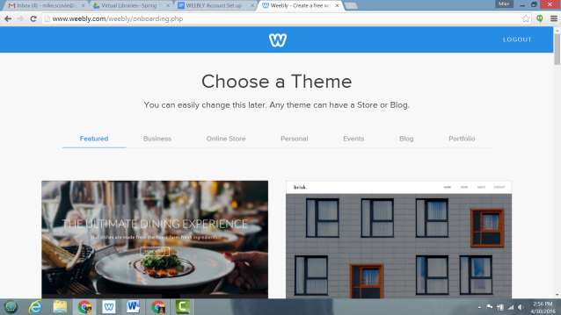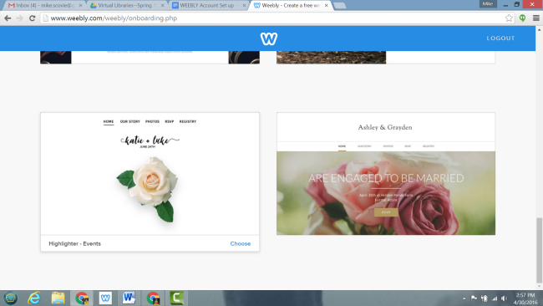 | -Pick your theme (Layout)  (this can be changed later)
3 | 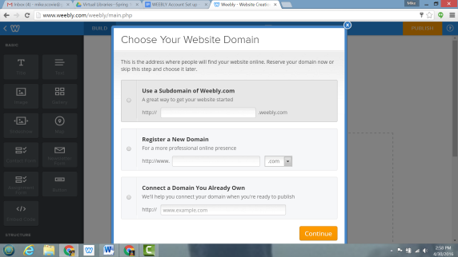 | -Select USE A SUBDOMAIN  OF WEEBLY.COM
4 | 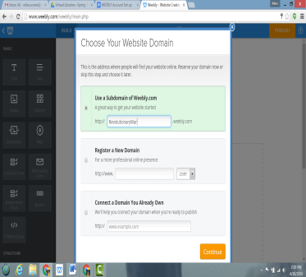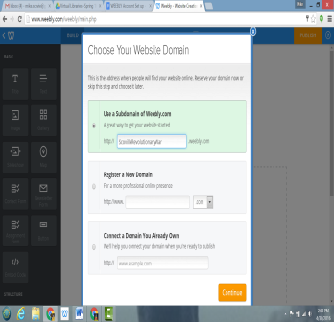 | -Create a domain name/site  Address--make sure it is  available. If not, try adding your  name.  -Click continue
5 | 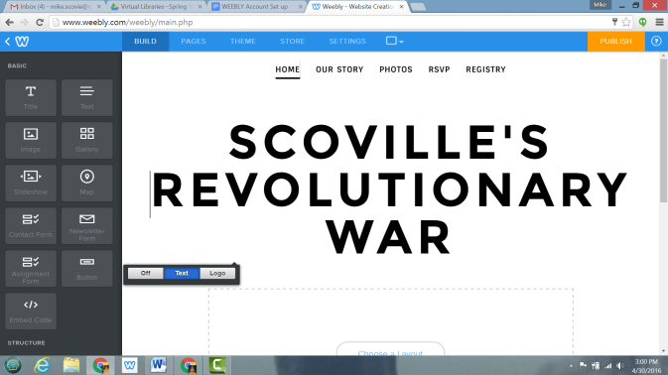 | -Title and upload a picture (if  so desired and if available on the  theme you selected).
6 | 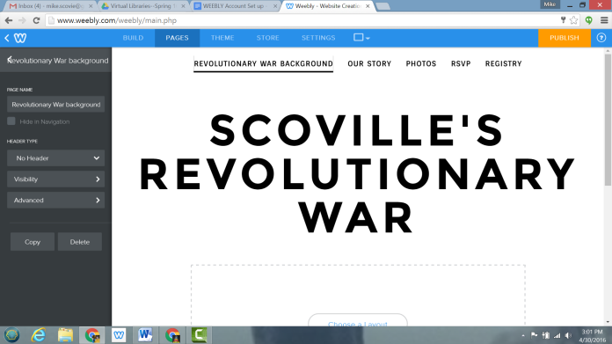 | -At the top, create your first page by  clicking on the PAGES tab.  -This should be the background of  the Revolutionary War  -The other pages already labeled in  the layout you chose can be  deleted by clicking on them and  selecting DELETE.
7 | 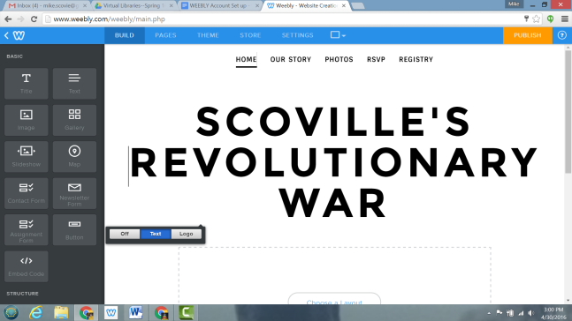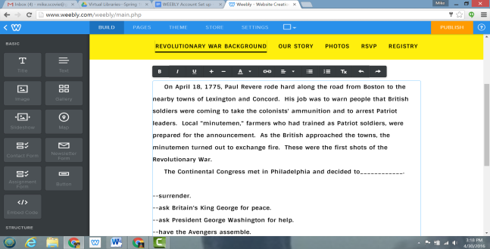 | -At the top, Click on BUILD to build  your site by dragging a text box  to the page.  -At the end of the first page, write  your choices. The reader will  need to pick the consequence  they believe is correct.
8 | 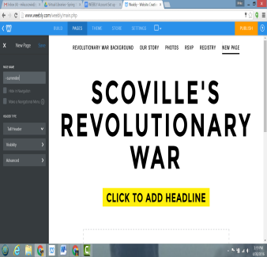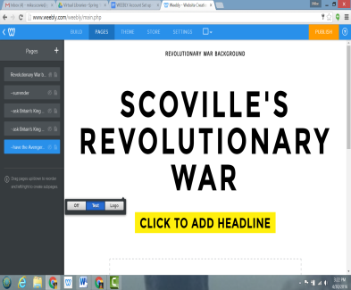 | -At the top, create your pages.  -Add a STANDARD page.  -Title the page as one of your  choices. Right under the title,  click the box for Hidden in  Navigation. SAVE. This page will  not appear to the person looking  at the web page online.
9 | 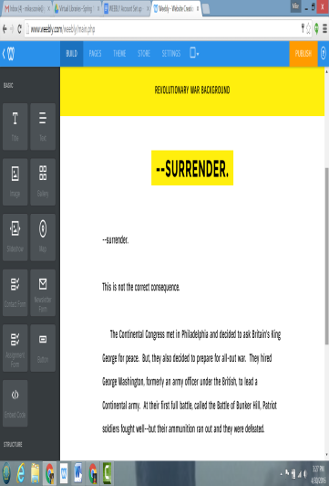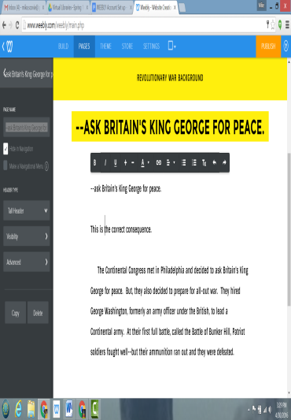 | -Build each page by dragging a  text box. If you want to adjust  the font size, color, pictures,  etc. please do so.  -In the text box, add the choice  and then the consequence of  the choice. What happens if  the reader picks that choice?  -Does this consequence lead to  another set of choices? If so,  you will need to repeat steps  8-9. Each new  choice/consequence is a new  page in the build tab.
10 | 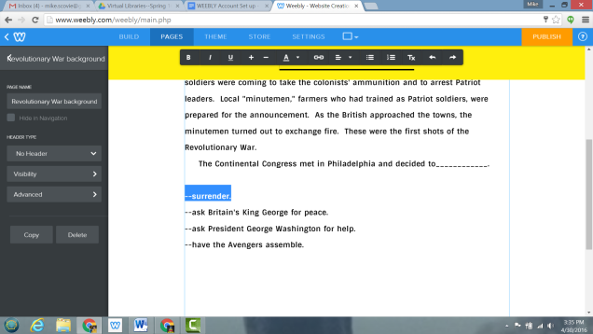 | -How to hyperlink the choices and  consequences.  -Go back to the first page.  Highlight the first choice. A  menu bar will show up right by  the highlighted text. Click the  icon that looks like chain links.
11 | 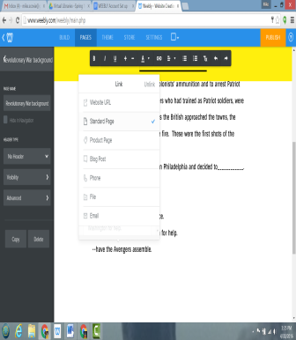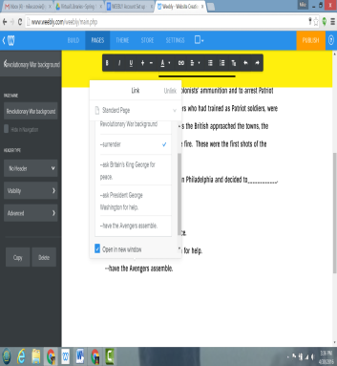 | -Select STANDARD page from  choices.  -Then, use the drop down box to  select the page you wish to link  to. It would be a suggestion  here to click the box to open  the link in a new window.
12 | 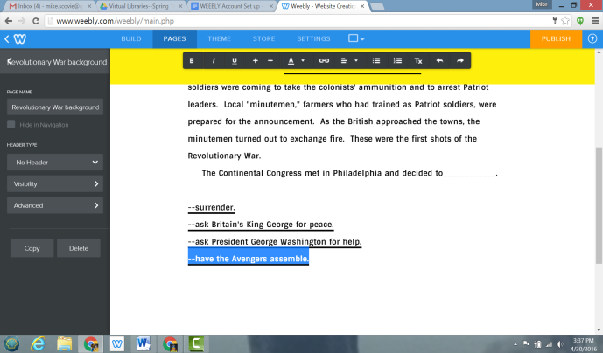 | -Repeat the steps above to  complete your review of the  Revolutionary War with  hyperlinks to choices and  consequences.
13 | 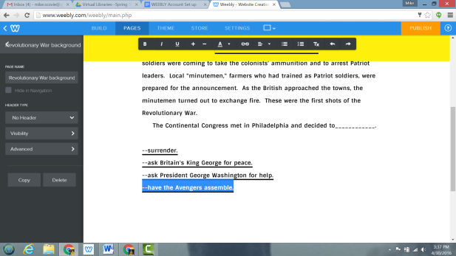 | -When you are ready, publish to  web by clicking the orange  PUBLISH button on the top.
14 | 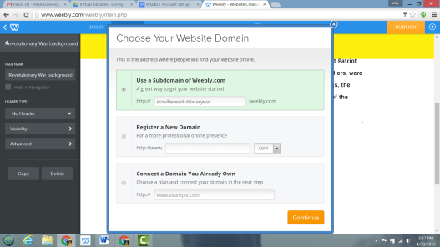 | -The first time you publish your  new site, verify the domain title.  -Click continue.
15 | 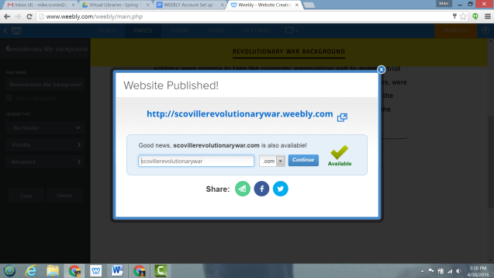 | -A screen will pop up to verify that  your website is published.  -DO NOT DO ANYTHING ELSE!
16 | 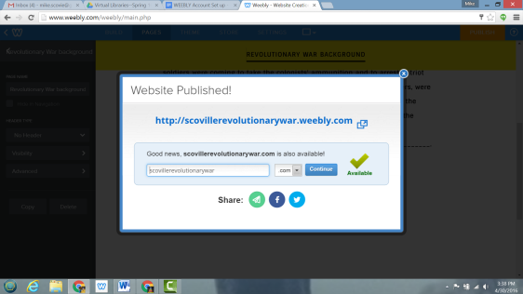 | -If you want to see what your site  looks like, click on the link right  under the words WEBSITE  PUBLISHED.
17 | 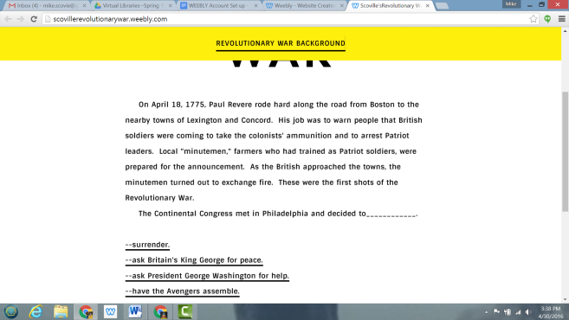 | -If you need to make edits, click on  the X in the upper right corner  to continue working on your  site. Remember, that if you  made edits, you will need to \  publish your site again for the  changes to take place.  -If you are done, logout.

